

**Artificial Intelligence and Data Science Department.**

OOPM / Odd Sem 2021-22 / Experiment 5.

YASH SARANG.

47 / D6AD.

EXPERIMENT - 5.

**_________________________________________________________________**

**AIM:** a. Consider a class Figure and overload the function called area () to display the area of figures like square, triangle, rectangle, and circle.

b. Write a Program for Complex Number addition using Constructor.

**_________________________________________________________________**

**THEORY:** Explain following concepts in detail

1. Constructors
2. Access
3. Specifiers
4. Abstract Classes
5. Wrapper Classes
6. Inheritance
7. Polymorphism
8. Method Overriding
9. Keyword-Static, final, Super and this.

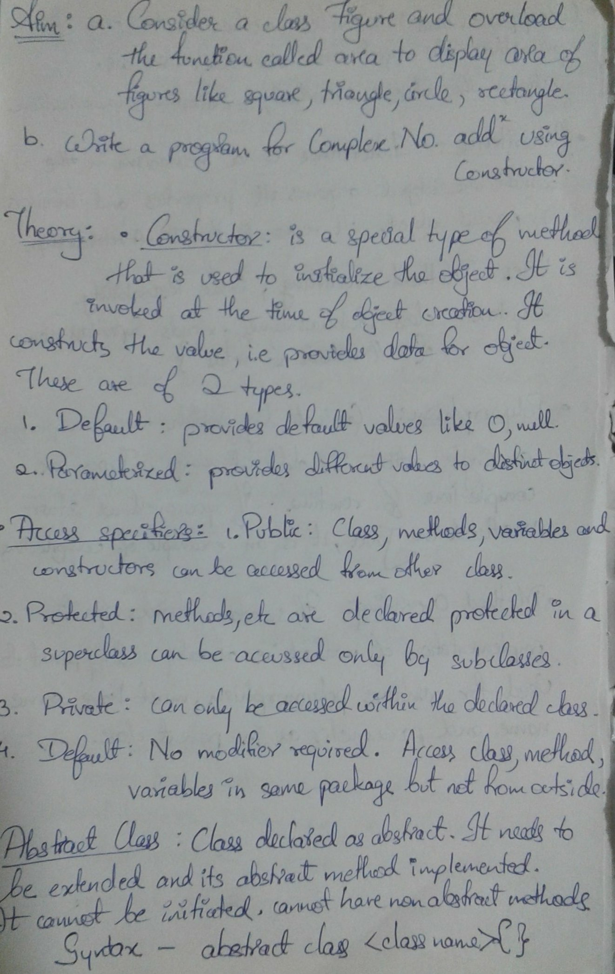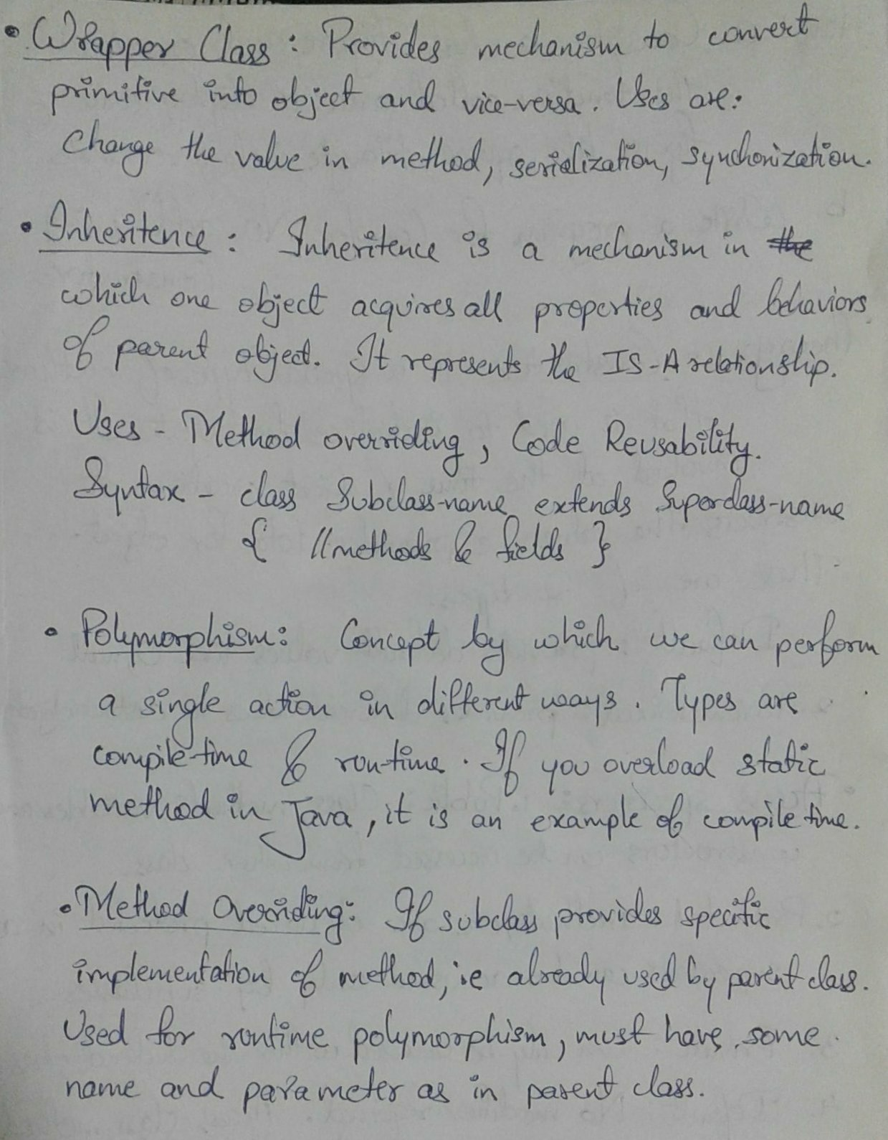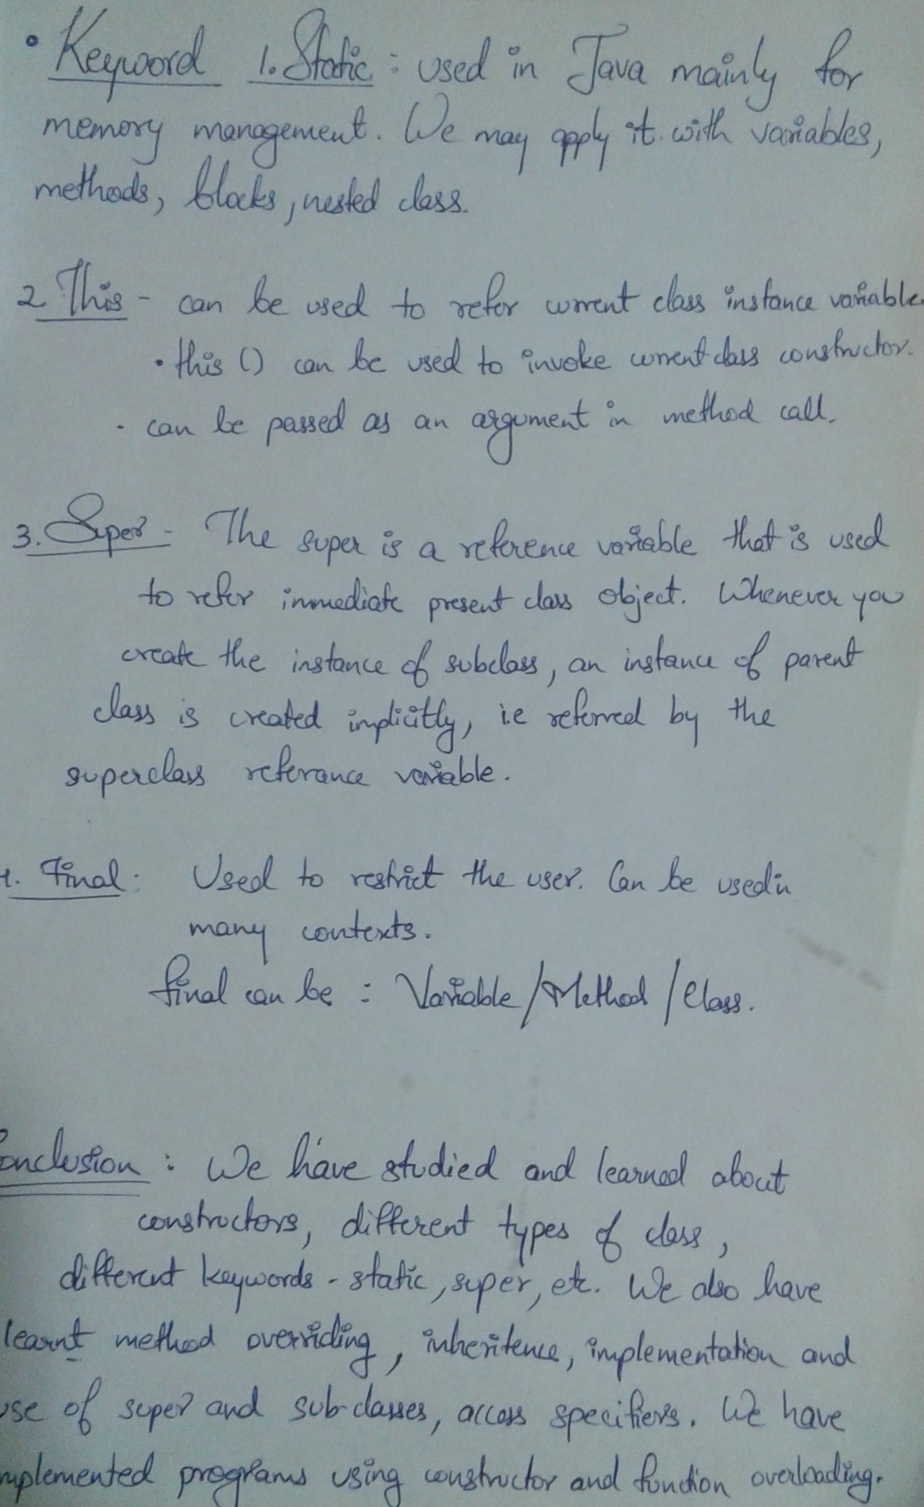

**_________________________________________________________________**

**Program 1:** Consider a class Figure and overload the function called area () to display the area of figures like square, triangle, rectangle, and circle.

import java.util.Scanner;

class Figure

{

public int area(int s)

{

// Area of square

return s*s;

}

public double area(double h, double b)

{

// Area of triangle

return 0.5*h*b;

}

public int area(int l,int b)

{

// Area of Rectangle

return l*b;

}

public double area(double r)

{

// Area of Circle

return 3.14*r*r;

}

public static void main(String[] args)

{

Figure a = new Figure();

System.out.println("Area of Square: "+a.area(4));

System.out.println("Area of Circle: "+a.area(5.0));

System.out.println("Area of Triangle: "+a.area(3.0,4.0));

System.out.println("Area of Rectangle: "+a.area(4,5));

}

}

**The output of program 1:**

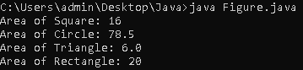

**_________________________________________________________________**

**Program 2:** Write a Program for Complex Number addition using Constructor.

import java.lang.*;

import java.util.*;

class Complex

{

double real,imaginary;

Complex(double real,double imaginary)

{

this.real = real;

this.imaginary = imaginary;

}

void display()

{

System.out.println(real + " + " + imaginary + " i");

}

static Complex sum(Complex c1,Complex c2)

{

Complex addition = new Complex(0,0);

addition.real = c1.real + c2.real;

addition.imaginary = c1.imaginary + c2.imaginary;

return addition;

}

public static void main(String[] args)

{

Scanner sc = new Scanner(System.in);

System.out.print("Enter Real & Img. part of 1st no. : ");

double a = sc.nextInt();

double b = sc.nextInt();

Complex c1 = new Complex(a,b);

System.out.print("Enter Real & Img. part of 2nd no. : ");

double c = sc.nextInt();

double d =sc.nextInt();

Complex c2 = new Complex(c,d);

c1.display();

c2.display();

Complex addition = sum(c1,c2);

System.out.println("The sum is: "+ addition.real+" + "+ addition.imaginary+"i");

}

}

**The output of program 2:**



